Supplementary Figures and Tables
  - Supplementary Figures
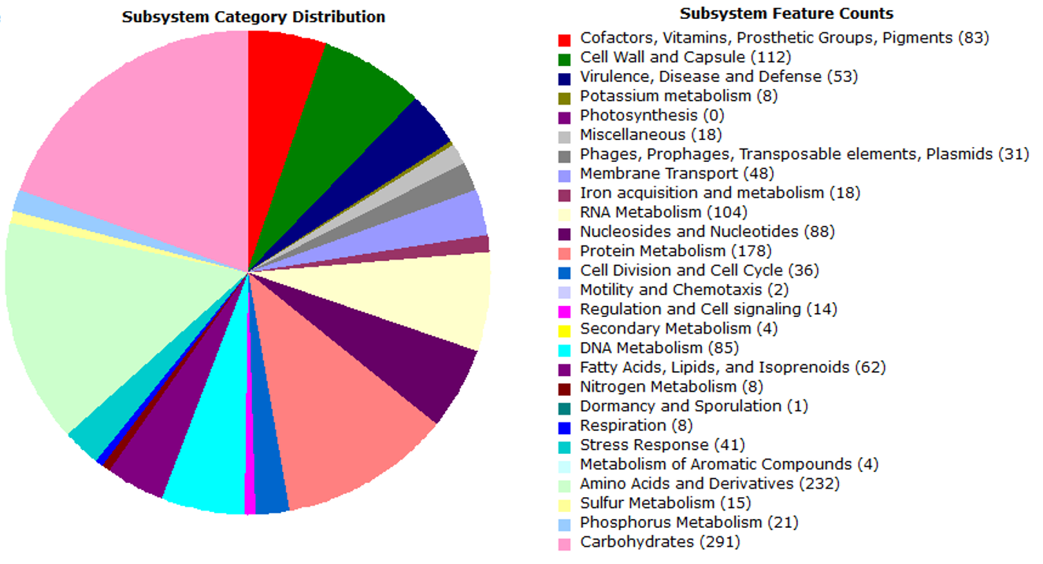
Supplementary Fig. S1. The subsystem category distribution of strain Lactococcus raffinolactis WiKim0068. A total of 1,565 proteins were categorized within these subsystems.

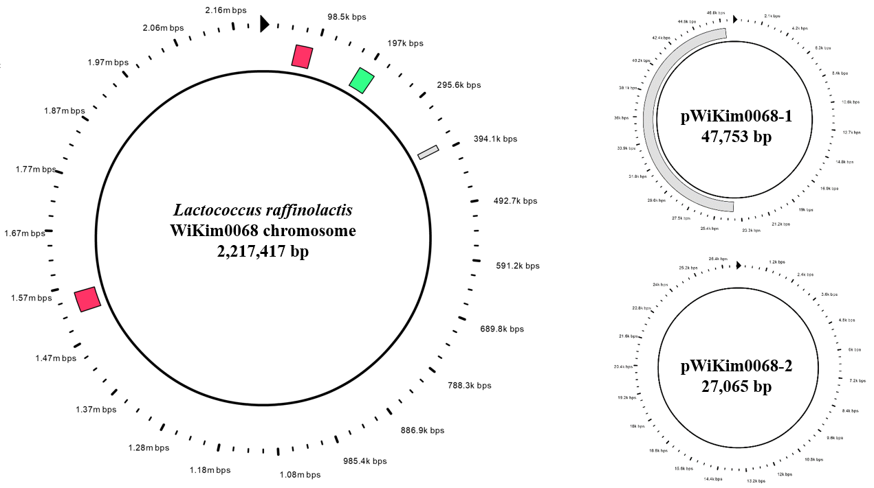
Supplementary Fig. S2. Prophages of Lactococcus raffinolactis WiKim0068 identified using the PHAse Search Tool (PHAST). Intact prophage, red; questionable prophage, green; incomplete prophage, gray.

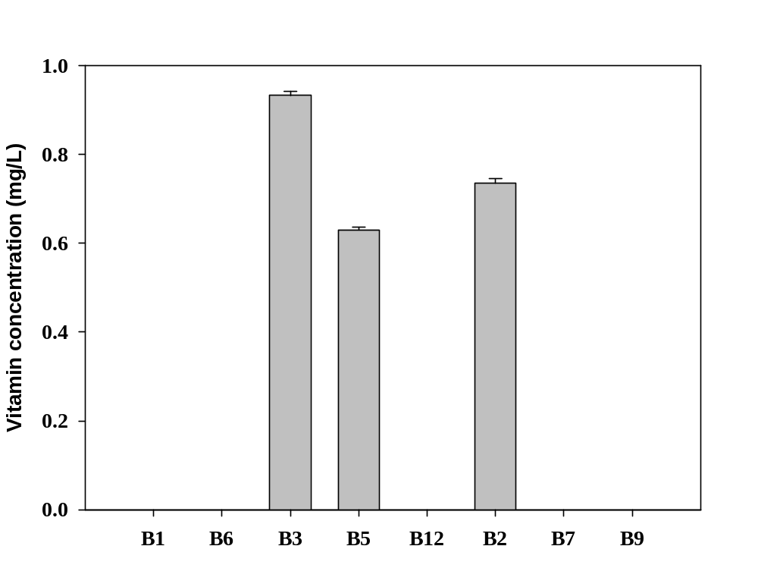
Supplementary Fig. S3. Vitamin B concentration in Lactococcus raffinolactis WiKim0068. B1, vitamin B1 (thiamin); B6, vitamin B6 (pyridoxine); B3, vitamin B3 (nicotinate); B5, vitamin B5 (pantothenic acid); B12, vitamin B12 (cobalamin); B2, vitamin B2 (riboflavin); B7, vitamin B7 (biotin); B9, vitamin B9 (folic acid). All experiments were repeated at least three times.

  - Supplementary Tables
Supplementary Table S1. Genes associated with general COG functional categories in genome of Lactococcus raffinolactis WiKim0068.
COG | Description | Number of genes | %
C | Energy production and conversion | 73 | 3.6
D | Cell cycle control, cell division, chromosome partitioning | 28 | 1.4
E | Amino acid transport and metabolism | 180 | 9
F | Nucleotide transport and metabolism | 80 | 4
G | Carbohydrate transport and metabolism | 210 | 10.5
H | Coenzyme transport and metabolism | 70 | 3.5
I | Lipid transport and metabolism | 42 | 2.1
J | Translation, ribosomal structure, and biogenesis | 146 | 7.3
K | Transcription | 152 | 7.6
L | Replication, recombination, and repair | 158 | 7.9
M | Cell wall/membrane/envelope biogenesis | 108 | 5.4
N | Cell motility | 8 | 0.4
O | Posttranslational modification, protein turnover, chaperones | 54 | 2.7
P | Inorganic ion transport and metabolism | 99 | 4.9
Q | Secondary metabolites biosynthesis, transport, and catabolism | 15 | 0.7
R | General function prediction only | 237 | 11.9
S | Function unknown | 190 | 9.5
T | Signal transduction mechanisms | 61 | 3.1
U | Intracellular trafficking, secretion, and vesicular transport | 26 | 1.3
V | Defense mechanisms | 63 | 3.2
Total |  | 2000 | 100

